- Write the following application. The initial page is called Validator.aspx and it has 7 text boxes representing (Name, Family Name, Address, City, Zip Code, Phone and e-mail address) and a Check button.

User gets the following page after clicking on Check button:
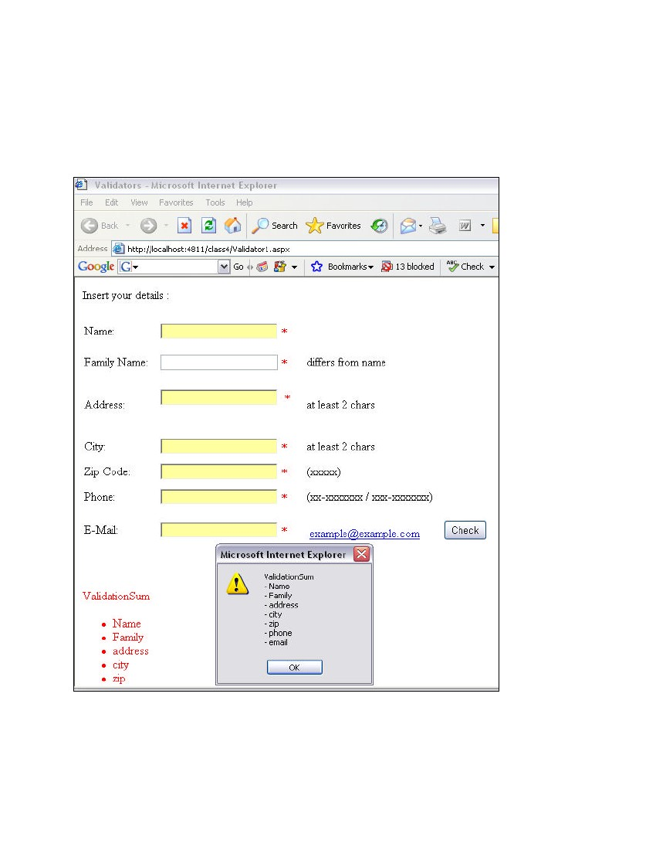

The required validation actions are:
- name different from family name,
- address at least 2 letters,
- city at least 2 letters,
- zip-code 5 digits,
- phone according to the format XX-XXXXXXX or XXX-XXXXXXX,
e-mail is a valid email.

2. Create a web application that hosts a series of products (any produc) as a dropdown list.
Have an image control that can display the image of the selected item in the dropdown
have a button control that gets the price of the selected product and displays it in a Label control

